The Cizik Nursing Research Institute
Rationale
Nursing Research is the scientific basis for the health of the public.
Nursing is the backbone of the health of the public, as the largest global healthcare profession, the largest profession in the US workforce, and the most trusted profession in the US for over 20 years. As nursing research is the scientific basis for the practice of nursing, it is thus the scientific basis for the health of the public and is part of the profession’s societal mandate. Nursing practice focuses on the actual or potential human response to health conditions and life processes of individuals, families, communities, and populations under our care, in an ecological context. Nurses diagnose in 4 areas – problem-focused, risk, health promotion, and syndrome - with these diagnoses guiding selection of interventions to achieve optimal patient outcomes. Nursing science provides the foundation for (1) how we assess and form diagnoses (2) the availability of interventions to support the patient (3) selection of outcomes to monitor response and (4) timing of our care.
The nursing metaparadigm represents the unique perspective of nursing, with its concepts distinguishing nursing from other disciplines. These concepts include person, health, environment, and nursing – with the impact of nursing knowledge coming from the discipline’s focus on the dynamic interrelations of these concepts. Thus, nursing science’s unique perspective on health has a holistic focus situating health within the context of how and where people live. The discipline is guided by assumptions such as people (including their biological and genetic traits) are inseparable from their environment, physical health is integrally related to psychological and spiritual wellbeing, and that people’s memberships in families and communities impact their health beliefs and behaviors. The meta-paradigm of nursing science is so fundamental to the practice of nursing that it serves as the basis of funding initiatives for the National Institute of Nursing Research. The meta-paradigm also serves as the framework for the Cizik Nursing Institute, with cores designed to synergistically work together to support this holistic perspective of health and behavior.
Creative interdisciplinary solutions to grow the nursing scientist pipeline are needed given nursing workforce issues.
The US workforce is projected to have a shortage of almost 1 million registered nurses by 2030. The nursing workforce shortage, fueled by decreased enrollment in nursing programs nationwide, also means the shortage of doctorly-prepared nurse scientists will continue to grow. Less than 1% of the nursing workforce holds a PhD, and enrollments in research-focused doctorates have dropped 12% since 2012 (AACN). Nurses obtain PhDs much later than other disciplines (average age 49 years vs 31 years), meaning there is less time to grow into independent senior-stage nurse scientists who can mentor new cohorts of ESI nurse scientists. Thus, creative interdisciplinary solutions are needed to grow the nursing scientist pipeline including creating opportunities for mentorship across all career stages and supporting collaborative interdisciplinary research teams. With a large and robust research enterprise, the CSON will begin attracting more BSN-PhD and international PhD applicants and be able to grow the pipeline of future nurse scientists.
Furthermore, strategic hiring of nurse and non-nurse faculty who synergistically align with the CSON and institute’s members are needed for CSON to remain competitive. The 4 top-ranked nursing schools have an average of 23 funded faculty, 33% of whom are not nurses, leading an average of 37 projects (see Table 1). Furthermore, approximately half of the projects are MPI. The CSON currently only has 15 research faculty of whom only 6 have NIH funding, and only 2 as interdisciplinary MPI. The institute will help us to strategically recruit researchers to the CSON, as well as other schools through offering institute membership and resources, thus increasing the amount of PI and MPI applications involving a nurse scientist. Additionally, the top-ranked schools all have institutes or centers focused on aging/ADRD, informatics and/or HIV led by the non-nurse scientists to boost their rankings. The Cizik Nursing Research Institute was strategically designed to not be thematic to a specific population or disease, rather aligned with the overarching mission of the NINR and nursing practice so that it can remain competitive and responsive through changes in funding priorities (NINR updates every 5 years).
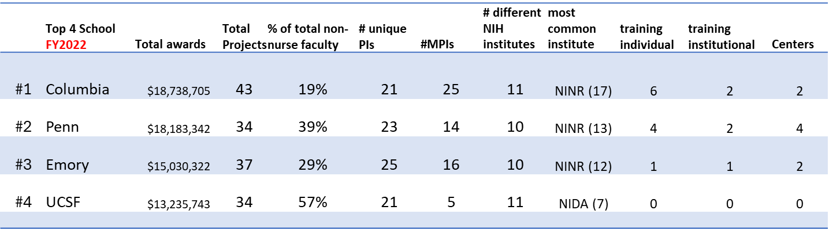
The CSON research ranking has organically grown to #18 nationally, and #1 in Texas. To continue increasing the impact of our research, and compete with top-4 ranked schools, robust services and infrastructure are needed to match funding trends and support our momentum. The current NINR strategic plan emphasizes four guiding principles for their portfolio including (1) addressing current real-time issues impacting health (e.g., gun violence, social isolation) (2) finding solutions across settings to promote health of individuals, families, and communities (e.g., alignment with nursing practice) (3) removing structural barriers to conduct and participation in research (e.g., health equity) and (4) using most innovative and rigorous methods (e.g., epigenetics, informatics). Dedicated infrastructure and resources, along with a means of supporting interdisciplinary research on nursing issues, is especially important for responding to NINR’s emphasis on real-time issues as their RFAs often have <9-month window to apply. Being able to competitively respond to these quick turnaround grants requires having existing partnerships, collaborations, data, and resources available. The strategic plans for the Cizik Nursing Research Institute are designed to encourage long-term growth of the Institute’s research portfolio and increasing the ranking of both the CSON and our other schools. To reach a top-10 ranking among nursing schools in 2029, it is estimated we will need a minimum of $9.5 million (Appendix C). Through increasing the size of CSON faculty and available collaborators and providing dedicated infrastructure and resources to supportive interdisciplinary research focused on nursing issues, we should be able to achieve top-10 status and sustainably remain ranked.
Institute Description
Purpose: The purpose of the Cizik Nursing Research Institute is to cultivate a dynamic environment dedicated to advancing nursing science through innovative research, collaboration, and interdisciplinary inquiry. With a commitment to excellence, our institute aims to facilitate the development and dissemination of evidence-based knowledge that informs and enhances the practice of nursing. By providing robust organizational support, cutting-edge infrastructure, and ample resources, we endeavor to empower researchers to conduct impactful, responsive, and rigorous studies addressing the complex healthcare needs of individuals, families, communities, and populations, consistent with the nursing scope of practice. Through fostering a culture of collaboration and knowledge exchange, our institute strives to contribute significantly to the advancement of nursing practice and policy, ultimately improving the health and well-being of society.
Vision: To be the leader among academic nursing programs in the conduct of impactful, responsive, and rigorous nursing science.
Mission: To provide organization, infrastructure, and resources that accelerate the growth of collaborative, interdisciplinary science, which informs the practice of nursing.
Logic Model (Appendix A).
The Cizik Nursing Research Institute will have 5 cores: (1) Administrative core (2) Research Informatics Core (3) Biobehavioral Health Core (4) Vulnerable Populations Core and (5) Clinical Innovations and Translational Nursing Science Core. These cores reflect the strengths of the CSON nursing faculty and UTH schools, and priorities of the NINR, particularly related to behavioral health, healthy equity for disadvantaged and marginalized groups and community health promotion. These cores also highlight scientific areas that are strengths across the UTHealth campus, which will build synergy and allow for robust institute membership and future collaborations (Fig. 1).

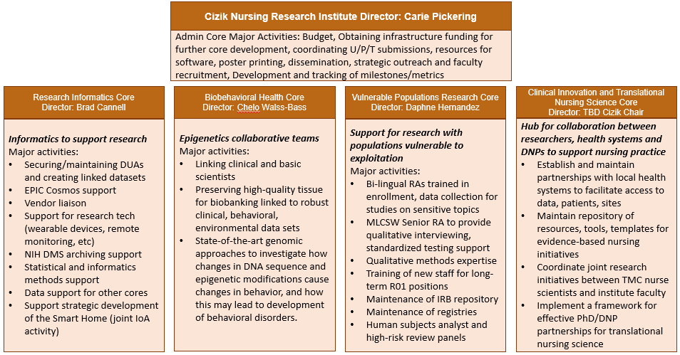
Figure 1 CNRI Core Overview
Administrative Core
The Administrative Core of the Cizik Nursing Research Institute plays a pivotal role in steering the institute towards achieving its mission and strategic goals. Tasked with the comprehensive management of the institute's budget, funding initiatives, and strategic collaborations, this core ensures the smooth operation and long-term growth of the institute. By coordinating major grant submissions, providing essential resources, and fostering partnerships, the Admin Core underpins the research excellence and collaborative spirit of the institute. Additionally, it focuses on the development and monitoring of performance metrics, facilitating effective communication between different cores, and organizing events to bolster networking and collaborative research efforts.
Goals:
- Financial and Resource Management: Ensure efficient management of the institute's budget and secure additional funding to support core development and research activities.
- Strategic Collaborations and Growth: Build and maintain strategic partnerships, recruit new faculty, and identify potential institute members to expand the institute's research capacity and impact.
- Performance Monitoring and Strategic Planning: Develop, implement, and track performance metrics to guide the institute's strategic direction and update plans to meet evolving research goals.
- Foster Research Collaboration and Community: Support and enhance collaboration among different research cores and the broader research community, ensuring a cohesive and synergistic research environment.
Activities:
- Oversee the institute's budget, identify opportunities for funding of infrastructure and major initiatives, and coordinate grant submissions for significant NIH mechanisms like U, P, and T grants.
- Provide researchers with necessary resources such as software, travel funds, and support for poster printing, facilitating their research and dissemination efforts.
- Engage in outreach activities to forge new partnerships, recruit talented faculty, and integrate UTH faculty who align with the institute's vision and objectives.
- Create and monitor performance metrics, use these metrics to refine strategic plans, and ensure alignment with the institute's goals and achievements.
- Plan and execute an annual retreat to showcase successes, identify new opportunities, and enhance networking and collaboration among institute members and external partners.
- Serve as the primary point of contact with the internal advisory committee, ensuring their insights and feedback inform institute strategies and operations.
Research Informatics Core
Overview: The overarching purpose of the Research Informatics Core (RIC) is to integrate informatics into nursing research to enhance the quality, efficiency, and impact of healthcare outcomes. The RIC will achieve this by making advanced informatics tools and methodologies easily accessible; housing and managing data; and fostering collaborations among UTHealth faculty, students, and staff engaged in nursing research.
Goals:
- Establish and Enhance Informatics Infrastructure: To build and continuously upgrade a robust informatics infrastructure that supports the collection, storage, and analysis of healthcare, social, environmental, and other public data sources, facilitating cutting-edge nursing research.
- Foster Interdisciplinary Collaborations: To act as a catalyst for interdisciplinary research by bridging the gap between nursing researchers and informatics technology, enhancing the scope and impact of studies.
- Empower Researchers with Informatics Tools and Training: To provide comprehensive training and access to advanced informatics tools, enabling researchers to conduct sophisticated analyses, identify collaborators, and translate findings into actionable insights that support the practice of nursing.
- Streamline Research Processes: To simplify and expedite research workflows through standardized protocols, data use agreements, and access to diverse data sources, allowing researchers to focus on innovation and discovery.
Activities:
- Develop a state-of-the-art data management infrastructure that includes a robust data warehouse from multiple sources and advanced technological tools. This infrastructure will support efficient data aggregation, standardization, and utilization, enabling researchers to seamlessly access, analyze, and interpret vast datasets. The core will continuously update and upgrade these technological resources to keep pace with advances in informatics, ensuring that researchers have access to the most cutting-edge tools and most relevant data for their studies.
- Engage in strategic negotiations and collaborations with key data providers, such as STRAC and state agencies (e.g., vital records, criminal justice), to secure access to data critical to understanding the socioecological contexts of health. These efforts will involve identifying mutual benefits, drafting proposals, and establishing formal access agreements. Access to these diverse data sources will enable researchers to conduct more comprehensive and impactful studies, and be more responsive to NIH priorities, leading to significant advancements in nursing and public health research.
- Establish a streamlined process for research approval that includes the development of an umbrella IRB protocol and standardized data use agreements. This process will significantly reduce the time from study conception to approval, facilitating quicker start times for research projects. By consulting with legal, compliance departments, and institutional leadership, the core will ensure these protocols and agreements meet all regulatory requirements while simplifying the research initiation process for institute members.
- Implement a multifaceted training program that covers basic to advanced analytics, including the use of Epic Cosmos, Large Language Models and other informatics tools (e.g., remote monitoring, wearables). The program will be designed to cater to a range of skill levels, from novices to experienced researchers, with the goal of enhancing participants' ability to apply informatics technologies/methodologies and collaborative opportunities to increase the number of impactful interdisciplinary funded projects.
Biobehavioral Health Research Core
Overview: Despite tremendous advances in genetics, molecular/cellular biology, and psychopharmacology, the fundamental biological nature of behavioral disorders remains largely elusive. In order to understand the biology behind behavioral disorders, a model of collaboration and dialogue between investigators working in the laboratory and investigators working directly with patients is needed, to correlate behavioral outcomes with genetic underpinnings and biological mechanisms.
The Biobehavioral Core will serve as the link between clinical and basic science researchers. We will obtain and preserve high-quality tissue from patients, such as blood and saliva, in combination with extensive clinical and sociodemographic data, to drive evidence-based research. Working with researchers, we will utilize state-of-the-art genomic approaches to investigate how changes in DNA sequence and epigenetic modifications cause changes in behavior, and how this may lead to development of behavioral disorders.
Goals:
- Advance Understanding of Behavioral Disorders: Enhance the scientific community's understanding of the biological basis of behavioral disorders by fostering collaborative research that integrates clinical observations with genetic, epigenetic, and molecular biology findings.
- Facilitate Translational Research: Bridge the gap between basic scientific discoveries and clinical applications to accelerate the development of novel approaches to diagnosis, management and prevention of behavioral disorders.
- Promote Research Innovation and Education: Serve as a hub for innovation in research methodologies and as a training ground for researchers and students in the field of biobehavioral health that can promote growth of interdisciplinary teams.
Activities:
- Facilitate joint projects between laboratory scientists and clinical researchers to explore the genetic and epigenetic underpinnings of behavioral outcomes, leveraging state-of-the-art genomic technologies, paired with robust clinical, environmental and observational data for holistic assessments.
- Establish and maintain a biobank of high-quality biological samples (blood, saliva) coupled with detailed clinical and sociodemographic data from patients with behavioral disorders.
- Provide services related to epigenetics of behavioral health to support interdisciplinary research teams including:
  - Cellular and Molecular Analysis of Biological Samples: Offering services for the processing and analysis of biological samples, such as blood and saliva, this core will provide researchers with detailed insights into cellular and molecular mechanisms. These analyses will support investigations into how genetic and epigenetic factors influence behavior and contribute to behavioral disorders.
  - Dynamic Cell Behavior Monitoring and Single-Cell Analysis: This service will enable researchers to observe and analyze cell behaviors in real time and at the single-cell level. By examining how cells respond to various genetic and epigenetic modifications, scientists can gain a deeper understanding of the cellular basis of behavioral phenotypes and disorders.
  - Spatial Analysis and Sequencing: With capabilities for detailed spatial analysis and high-throughput sequencing, the core will facilitate the exploration of gene expression patterns and biomarker discovery within complex tissue environments. This comprehensive approach will help uncover the intricate interactions that underlie behavioral health and disorders, offering new avenues for research.
  - Advanced Imaging and Genetic Modification Analysis: Providing advanced imaging services and analysis of genetic modifications, such as DNA methylation, the core will support studies on the epigenetic mechanisms affecting gene expression related to behavior. This will allow for high-resolution visualization and analysis of these effects across different tissue types, advancing our understanding of epigenetic influences on behavior.
- Develop and implement advanced data integration and analysis platforms to correlate clinical findings with molecular and genetic data, identifying key biological pathways involved in behavioral disorders.
- Organize workshops, seminars, and symposia on the latest research findings, techniques, and ethical considerations in biobehavioral health research, fostering a community of learning and collaboration.
Vulnerable Populations Research Core
Overview: The Vulnerable Populations Research Core (VPRC) will work together with the other cores of the Research Institute to develop and support research projects dedicated to reducing health disparities, promote health equity, and improving the health of marginalize and vulnerable populations. This core supports the entire research lifecycle, from IRB protocol development to data collection, with a strong emphasis on ethical standards, respect for persons, preservation of autonomy and trauma-informed practices. By integrating bilingual research assistants and qualitative method experts, the VPRC aims to include populations traditionally excluded from research, thus broadening the scope and impact of nursing research.
- Empower and Safeguard Vulnerable Populations in Research Endeavors: The Vulnerable Populations Research Core (VPRC) is committed to championing the ethical and respectful inclusion of highly vulnerable groups—such as individuals experiencing homelessness, cognitive impairments, substance use disorders, and victimization due to violence—in health research. Our goal is to ensure that projects and investigators are thoroughly supported in their efforts to engage these populations in ways that prioritize their respect, autonomy, and unique needs. We aim to foster an environment of empathy and creativity in problem-solving, allowing for the maintenance of rigorous research standards without compromising the dignity, autonomy, or specific requirements of these groups. This goal emphasizes the importance of inclusive research practices that recognize and address the barriers to participation faced by these populations.
- Bridge Clinical and Community Insights: Establish the VPRC as a pivotal bridge that connects clinical research with community-based insights, facilitating a deeper understanding of the health disparities and challenges faced by vulnerable populations. This involves fostering collaborations between researchers, community organizations, and the populations themselves to ensure that research is grounded in real-world experiences and needs.
- Cultivate Research Excellence in Health Equity: Develop and support a cadre of researchers who are not only skilled in cutting-edge research methodologies but are also deeply committed to health equity. This goal focuses on mentoring and training researchers, especially students and early career scholars, in conducting ethically sound and impactful research that contributes to reducing health disparities and advancing health equity.
Activities:
- The Human Subjects Analyst within the VPRC will work closely with research teams to review IRB protocols to ensure protocols meet compliance with federal and institutional regulations, while upholding standards of care and population-specific best research practices, prior to IRB submission. The Human Subjects Analyst will also facilitate “high-risk review” panels prior to IRB submission to provide feedback to the investigator, and IRB, on the balance of benefits, harms, standards of care and knowledge to be gained. To help guide investigators, Human Subjects Analyst will maintain a repository and be able to provide examples of IRB protocols, consent forms, recruitment flyers.
- Trained and supervised research assistants will be available to assist with data collection. Research assistants will be trained on how trauma can influence survey responses. In return, a trauma-informed approach to data collection will occur. Because there is a focus on including the populations that are traditionally excluded from research studies, research assistants that speak Spanish and Vietnamese, the 2 most popular languages spoken in Houston, will be a part of the VPRC. The bilingual research assistants will have the ability to translate research materials and recruit and conduct research studies in another language aside from English.
- Qualitative methods support will be provided by core faculty and facilitated by a Masters-prepared Licensed Clinical Social Worker. Expertise in qualitative methods is needed to review interview guides, conduct data collection, reviewing transcriptions, support data analysis and writing up of results. A MLCSW will have the clinical background to be able to use a trauma-informed approach to qualitative interviewing. MLCSW will also have the skills to deliver standardized testing, such as cognitive interviews, and be able to determine capacity to consent. The VPRC will also have available data collection supplies – ipads, hotspots, microphones and corresponding adaptors (for ipad hookup) for qualitative interviews.
- To help investigators enroll and retain hard-to-reach participants, the VPRC will create and maintain a repository of prior participants in research studies. The repository will be built from 1) current research studies where participants have agreed to be contacted in future research studies and 2) through community outreach. Dr. Hernandez has experience recruiting participants through health fairs and community events, such as back-to-school fairs and 5K walks. These recruitment events also serve as a valuable training opportunity for undergraduate and graduate students.
- The VPRC will also provide advice on building and supporting research teams with varied research experiences working with vulnerable populations. This includes writing up and implementing a manual of operating procedures. To ensure that the next generation of research scientists are being trained, the VPRC will provide support to teams that include students and early career scholars by providing them mentoring guidance and professional development support.
Clinical Innovation and Translational Nursing Science Core
Overview: This Core within our nursing research institute serves as a vital hub for fostering collaboration between academic researchers and partner health systems, including UTPhysicians. With a focus on enabling translational nursing science to promote evidence-based care, this core facilitates access to data, patients, and research sites for institute members, supports scholarly endeavors of Doctor of Nursing Practice (DNP) prepared faculty and staff, and fosters collaborative partnerships between PhD and DNP researchers. Additionally, the core provides expert guidance on study design for clinical trials and translational or implementation science projects related to nursing practice, ensuring rigor and relevance in research endeavors.
Goals:
- Facilitate Access and Collaboration: Build and maintain strong relationships with partner health systems to facilitate access to data, patients, and research sites for institute members.
- Support Scholarly Projects: Provide comprehensive support and resources to DNP prepared faculty members to enhance their scholarly projects and research initiatives.
- Foster Interdisciplinary Collaboration: Facilitate meaningful partnerships and collaborations between PhD researchers and DNP clinicians to promote translational research efforts in nursing science and enable evidence-based practice.
Activities:
- Establish a network of DNP faculty and staff across all UTHealth Schools and clinics, to provide means of networking, professional development and collaboration with the institute
- Establish and maintain partnerships with local health systems to facilitate access to data, patients, and research sites for institute members.
- Provide consultation and support to DNP prepared members in developing and executing their scholarly projects, including assistance with study design, data analysis, and dissemination.
- Organize networking events and forums to facilitate collaboration and knowledge exchange between PhD and DNP researchers.
- Offer workshops and training sessions on study design, methodology, and research best practices for researchers involved in clinical trials and translational or implementation science projects.
- Develop and maintain a repository of resources, tools, and templates for researchers to utilize in their evidence-based practice initiatives.
- Offer mentorship and guidance to PhD and DNP students engaged in collaborative research projects.
- Coordinate joint research initiatives between academic researchers and partner health systems, focusing on addressing pressing healthcare challenges and improving patient outcomes.
Organization
(Bios of directors + advisory committee members)
Carie Pickering, PhD, RN (CSON) – CNRI & Administrative Core Director
Brad Cannell, PhD, MPH (MMS, SPH, CSON) – Research Informatics Director
Dr. Cannell is a tenured associate professor, epidemiologist, gerontologist, and data scientist jointly appointed to the McGovern Medical School, School of Public Health, and Cizik School of Nursing at the University of Texas Health Science Center at Houston. Dr. Cannell’s program of research has focused on the preservation of physical and cognitive function, living and aging with disability, and understanding and preventing elder mistreatment. Additionally, he has a strong background and training in epidemiologic methods and predictive analytics. His expertise includes scientific writing – he has published more than 40 peer-reviewed journal articles, two textbook chapters, and one textbook; grant writing – he has secured more than $24 million in grant funding for research; project management – he has been the principal or co-investigator on multiple trials and observational studies in community and healthcare settings; teaching – he has taught 8 different courses at 3 different universities; public speaking – he has given numerous presentations and trainings; and data science – he is fluent in all major statistical programming languages.
Daphne Hernandez, PhD (CSON) – Vulnerable Populations Research Core Director
Chelo Walss-Bass, PhD (MMS/SBHS) – Biobehavioral Health Research Core Director
TBD (CSON) - Clinical Innovation and Translational Nursing Science Core Director: Fulfillment of this position will be accomplished through our year-1 strategic recruitment initiatives. The ideal candidate will be a tenured associate/professor researcher with a dual PhD/DNP degree, an accomplished track record of mentoring of DNP and clinical faculty, and a history of research collaborations with health systems.
Internal Advisory Committee
Sandy Hannemann, PhD, RN (CSON)
Ron Acierno, PhD (MMS/SBHS)
Xiaoqian Jiang, PhD (SBMI)
Kimberly Alleman, MSN, RN (CNO UTPhysicians) ??
See Appendix B for organizational chart.
Institute Membership
Institute Leadership – This consists of the CNRI Director, and the research core directors. Need to say something about funding support, existing endowments (like Cizik endowment for the institute, and Cizik chair for the TBN director) and working to obtain endowments for long-term support or other positions.
Core Faculty -This includes pre-identified faculty who receive efforted support from the institute to provide instrumental assistance with the research core’s goals and activities. These responsibilities will be managed by the core directors.
Institute Scholars – This includes the general membership of the Institute. The CNRI institute members will have unrestricted access to the services, resources and research cores. Initial members will be identified and invited by the internal advisory committee in collaboration with the institute leadership. Subsequently, new members can apply by submitting a (1) CV (2) statement of interest in CNRI and description of possible collaborative research opportunities and (3) letter of acknowledge from department chair (or direct supervisor). Membership renewal is contingent upon participating in the annual retreat, establishing a collaboration with another institute member (e.g., grant submission, paper, IRB approved protocol for pilot work) and interaction with at least one of the research cores (e.g., use of services, attending professional development activities or seminars).
Overlap & Synergies with other units at UTHealth Houston
The Cizik Nursing Research Institute has no direct overlap with other university departments, schools, or operating units. There are no other entities on camps that share the CNSI’s focus on nursing science to impact nursing practice. MD Anderson does have an epigenetics core; however, it is focused exclusively on cancer treatment and does not significantly overlap with the much broader focus of the CNSI’s proposed Behavioral Health Core. There are synergistic opportunities for collaborations on campus. For example, the School of Behavioral Health Sciences Trauma & Resiliency center is a natural clinical partner for researchers utilizing the biobehavioral health core and many researchers in the School of Public Health would be natural partners for the vulnerable populations research core.

State of Impact and Value to UTHealth Houston
School of Behavioral Health Sciences:
Approximately ~70% of the NINR’s portfolio is spent on behavioral health research. Over half of UTHealth’s actively funded NIH projects, and 90% of the CSON’s funded projects, are related to behavioral health. However, there is only one active NIH-funded project incorporating epigenetics and DNA methylation. There is also only one lab on campus with equipment and expertise to incorporate epigenetics and DNA methylation into biobehavioral health studies. Since epigenetics of behavioral health is a major focus of several NIH institutes, including the NINR, the lack of dedicated infrastructure to support epigenetics and biobehavioral research for the broader UTH research community is a missed opportunity. Providing a core that not only has the wet-lab capabilities to provide services to support epigenetics research but also has a pool of interdisciplinary scientists ready for collaboration will help recruit competitive researchers to the School of Behavioral Health Sciences.
School of Biomedical Informatics:
Innovative Collaborations: The Research Informatics Core of the institute could collaborate with faculty and students in developing cutting-edge solutions in health informatics, AI, and data science, enhancing research outcomes.
Shared Resources: Access to advanced data acquisition tools and databases managed by the institute could provide invaluable resources for student and faculty research projects.
Interdisciplinary Research: Opportunities for interdisciplinary research projects could expand the scope and depth of health informatics studies, integrating nursing science insights to develop more user-friendly and effective healthcare technologies.
School of Public Health:
Enhanced Focus on Vulnerable Populations: The Vulnerable Populations Research Core aligns with public health's mission to improve community health and equity, offering opportunities for joint research initiatives.
Data Analysis and IRB Support: The institute’s resources in qualitative data analysis and IRB support can significantly aid public health research, streamlining project execution. Additionally, the research informatics core can provide faculty with access to data, informatics training, and other resources in a much more streamlined way than is currently available. Simultaneously, the institute can benefit from creating linkages with the vast network of community and healthcare organizations who are already partnering with SPH faculty.
Policy Impact: Policy development is one of the core functions of public health. Nursing-Public Health partnerships facilitated through CNSI have the potential to use high-quality research findings to inform public health policy and practice, especially in areas of disease prevention, health promotion, and healthcare delivery.
McGovern Medical School
*great to include stats on numbers of DNPs in UTPhysicians and make case for ability to positively impact our clinics (patient care, savings time and resources) through supporting DNP scholarship
Clinical Research Synergies: The Clinical Innovations Core's focus on partnerships with health systems offers medical researchers new avenues for clinical studies, potentially accelerating translational research.
Biobehavioral Insights: The Biobehavioral Core's work in epigenetics and behavioral health can enrich medical research, offering deeper insights into the psychosocial factors affecting patient outcomes.
Interdisciplinary Education: Medical students and faculty can benefit from interdisciplinary education and training opportunities, enhancing understanding of the nursing perspective in patient care and research.
School of Dentistry
Interprofessional Collaboration: Opportunities for collaborative research in patient care practices, focusing on the integration of oral health into overall health and well-being.
Innovative Technology Use: Sharing insights on the use of mHealth and AI in improving patient care can lead to novel approaches in dental practice and research.
Population Health Research: Working with the Vulnerable Populations Research Core to address oral health disparities in disadvantaged communities, contributing to broader health equity.
School of Biomedical Sciences
Biobehavioral Research Expansion: Collaborations with the Biobehavioral Core can enrich studies in genetics, neuroscience, and behavioral science, offering a holistic view of health.
Technological Advancement: The institute’s focus on cutting-edge infrastructure and AI can provide biomedical sciences with new tools and methodologies for research.
Cross-disciplinary Training: Students and faculty can benefit from cross-disciplinary training and research opportunities, preparing them for diverse careers in academia, industry, and healthcare.
By fostering these collaborations, the Cizik Nursing Research Institute will not only enhance the practice and science of nursing but also significantly contribute to the broader mission of UTHealth Houston to improve healthcare through research, education, and clinical practice.
Metrics of Success
Consistent with the logic model, the initial short-term goals are focus on increasing collaborative research as evidenced by an increase in successfully funded MPI applications and mentored training awards, and success in responding to NINR’s quick-turn-around RFAs. Through achievement of these short-term goals, we can transition to focusing on development of thematic research centers (P30/P20s), institutional training awards (T32s) and large component multi-project applications (Us/Ps). Upon advice of the internal advisory committee, we will develop specific measurable targets to ensure progression towards these goals. We will also establish parameters to identify when these initial goals have been achieved and it is time for a new strategic plan. We anticipate that once these initial targets described in the logic model are met, the next iteration of the strategic plan will include expanding a focus on pre- and post-doctoral trainees and increasing opportunities for undergraduate researchers, as well as revised goals based on the latest NINR strategic plan.
Space requirements:

Budget:

Appendix A – Logic Model Supporting Inaugural Strategic Plans for the CNRI
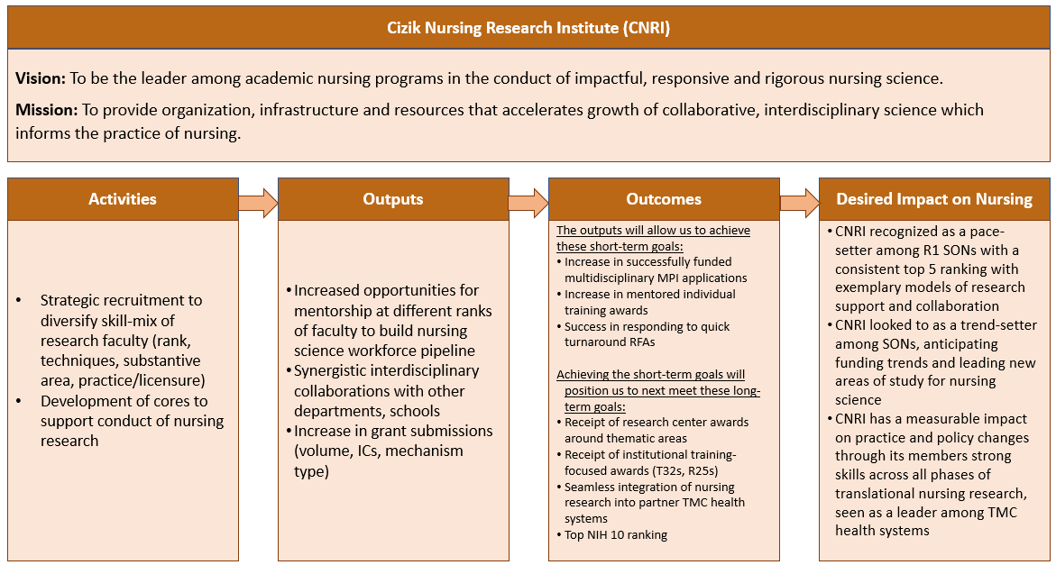

Appendix B – Organization of the CNRI [needs to be updated based on budget]
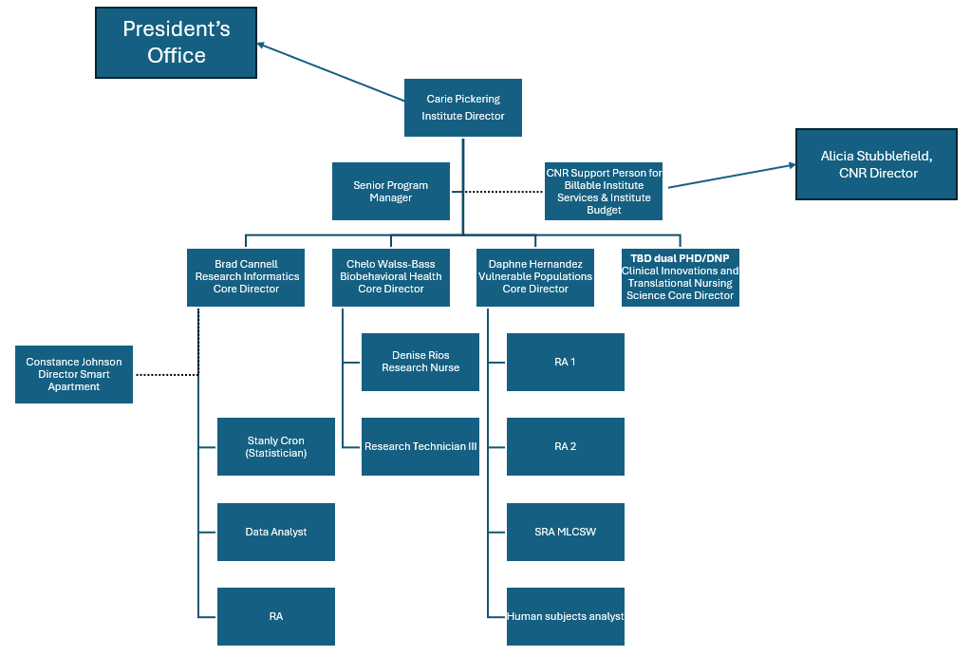
Appendix C – School of Nursing NIH Ranking Predictions
